Raised At Full Draw
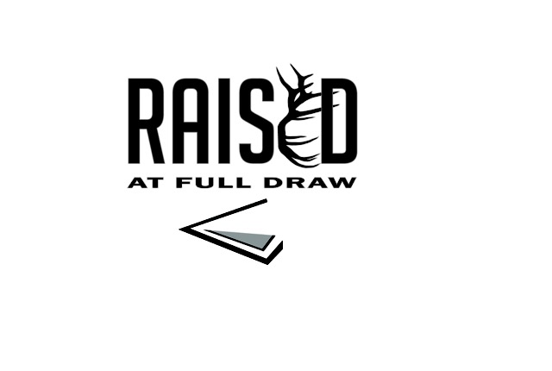
Registration Form
Camp State Location Wanting to attend: (Camp is first come, first served. If registration is mailed we will consider postal date listed). (Circle one) Missouri Iowa Michigan Montana North Dakota Wisconsin
Campers Full Name (First, Full Middle, Last):______________________________________________
Campers Date of Birth: _____________________ (12- 17 years old) Age your child will be attending camp ________ Male or Female (circle) Last Tetanus Date:__________________ Food or Drug Allergies:________________________________________
Current Medications including dosage and time taken: _____________________________________________________
Current Health Concerns that we should know about: ______________________________________________________
Hospitalizations/Injuries: _____________________________________________________________________________
Behavior: Has your child had any legal issues/been expelled from school for behavior: YES or NO (circle)
If you answered yes; please contact LaDonna Maxwell, MS, APRN at (406) 866-3589 for an interview to see if we
can accommodate your child’s needs at camp.
Will child need their Bow Hunter Education Certificate (no additional charge) YES or NO (circle)
Will child (circle): Need to Borrow a bow or Bringing their Own
Any Prior Archery Experience (circle): 0 1 2 3 4 5 6 7 8 9 10 (1 Beginner, 5 Intermediate, 10 Advanced)
T-Shirt Size:_____________________ Eye Dominate: Right Left Unsure (if you don’t know its okay)
Parent Information: Name: ______________________________________
Home Address: _________________________________________________________________
Home Phone Number: ______________________________ Emergency Contact Number: _________________________
Alternate Emergency Contact Name/Number: _____________________________________________
Email Address:___________________________________________
If someone else brings your child to camp: Name & Contact Number_____________________________
If traveling from a distance; Name & Contact info for someone less than 2 hours away: __________________________
I affirm that my child’s hunting privileges are not in any way currently revoked or suspended
in any state or country. YES or NO (circle)
Criminal Record: Has your child ever been charged or convicted of any crime? YES or NO (Circle)
Has your child been adjudicated or been titled a juvenile delinquent? YES or NO (circle)
Other helpful information that we should know about your camper: ________________________________________
________________________________________________________________________________________________
Camp Waiver and Release Form
The undersigned Parent or Guardian agrees to accept all responsibility, on behalf of the above-named Participant, for the risks, conditions, and hazards which may occur during the Raised at Full Draw Bowhunting camp, whether or not they are now known. Such risks, conditions, and hazards my include, but not be limited to, sunburn, dehydration, heat stroke, hypothermia, strenuous physical exertion, lacerations, broken bones, severe bodily injury, paralysis or even death associated with various outdoor activities, including, but not limited to: fishing, hiking, camping, and archery activities.
The undersigned Parent or Guardian agrees to WAIVE, RELEASE, DISCHARGE, AND HOLD HARMLESS Raised Hunting and Raised at Full Draw, and their officers, directors, agents, employees, volunteers, and representatives from any and all liability, to the greatest extent allowed by law, for any injury, accident, illness, death, loss or damage (including attorney's fees) arising out of or in connection with Raised at Full Draw Bowhunting Camp. This waiver, release, and discharge is made on behalf of the Participant, the Participant's family, heirs, personal representatives, assigns, and next of kin.
By signing this waiver and release as the Parent or Guardian, I am consenting to the Participant's participation in the Raised at Full Draw Bowhunting Camp. I have read the foregoing waiver and release, and I understand that all risk, whether known or unknown, is expressly assumed by me and all liability, to the greatest extent allowed by law, regarding Raised at Full Draw is expressly waived in advance. In the event of an emergency, I grant the Raised at Full Draw Bowhunting Camp personnel my permission to provide or obtain medical treatment on behalf of the Participant. By signing this form you are also agreeing to the consent of Use name and Likeness and Acknowledgement of RAFD Rules/Policies.

Our Policy
It is the policy of this organization to provide equal opportunities without regard to race, color, religion, national origin, gender, sexual preference, age, or disability.
I accept Terms and Conditions
By accepting, you agree to the terms and conditions in the Waiver and Release form and our policy above.
I agree I do not agree. (circle one)

Signature: _________________________________________________ Date: ______________________
Raised at Full Draw Bow Hunting Camp cost is $250 per participant. If you need assistants with camp registration fees, some participants are sponsored through an organization such as QDMA, WTU, RMEF or even local bowhunter clubs. If you have a sponsor, please write the organizations name and contact information incase we have not been informed.
Please make checks payable to Raised At Full Draw and include the participants name and state on memo line.
Mail to:
Raised At Full Draw
1221 E. Buchanan St
Winterset, IA 50273
Thank you for completing this application and for your interest in attending camp with us.
Raised At Full Draw reserves the right to refuse any application if we feel we are unable to fulfill our obligation as mentors; leaders; and role models. Thank you for your understanding.

